This primary source comes from the Records of the U.S. House of Representatives.

National Archives Identifier: [306687](https://catalog.archives.gov/id/306687)

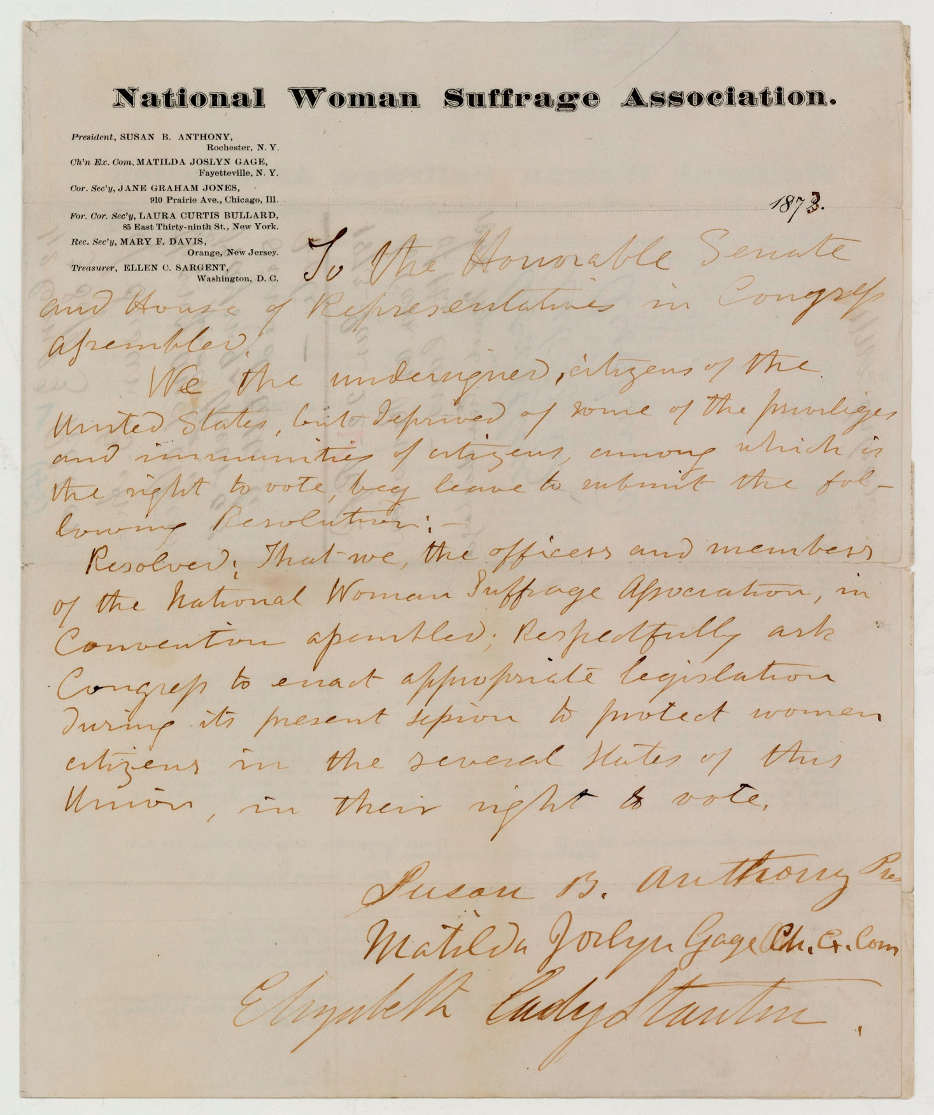

Full Citation: Petition to Congress from Susan B. Anthony, Matilda Joselyn Gage, and Elizabeth Cady Stanton of the National Woman Suffrage Association.; ca. 1/1873; Records of the U.S. House of Representatives, Record Group 233. [Online Version, https://www.docsteach.org/documents/document/petition-to-congress-from-susan-b-anthony-matilda-joselyn-gage-and-elizabeth-cady-stanton-of-the-national-woman-suffrage-association, September 10, 2016]

**Text of the Letter**

To the Honorable Senate and House of Representatives in Congress assembled,

We the undersigned, citizens of the United States, but deprived of some of the privileges and immunities of citizens, among which is the right to vote, beg leave to submit the following resolution:

Resolved: That we, the officers and members of the National Woman Suffrage Association, in Convention assembled; Respectfully ask Congress to enact appropriate legislation during its present session to protect women citizens in the several States of this Union, in their right to vote.

Susan B. Anthony, Pres.

Matilda Joslyn Gage Ch. Ex. Com

Elizabeth Cady Stanton