Mrs. E. Jackson wrote to the House Judiciary Committee the day after Bloody Sunday in Selma, Alabama. She was reacting to scenes of police brutality during a voting rights march that many Americans witnessed on television news programs. The interlined handwriting in pencil is likely that of House Judiciary Chairman Emanuel Celler, who was Mrs. Jackson's representative in Congress and an active supporter of voting rights legislation in the House.

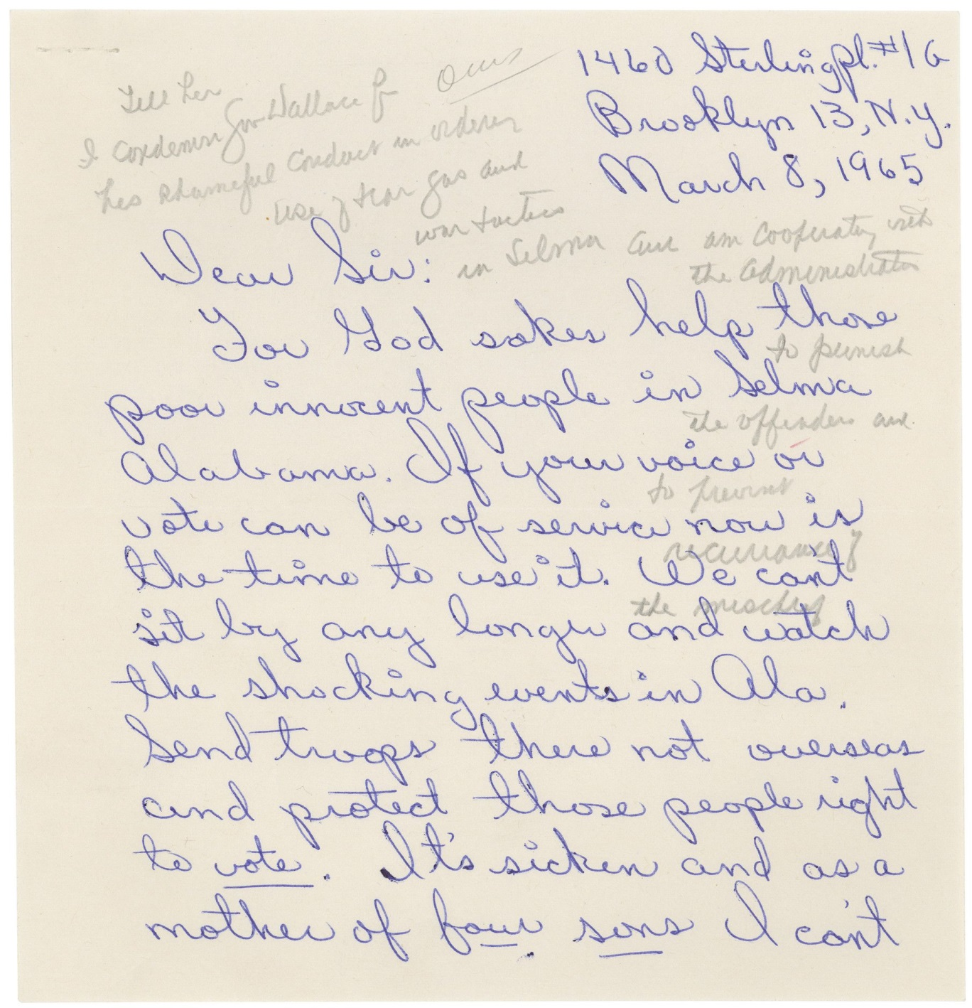

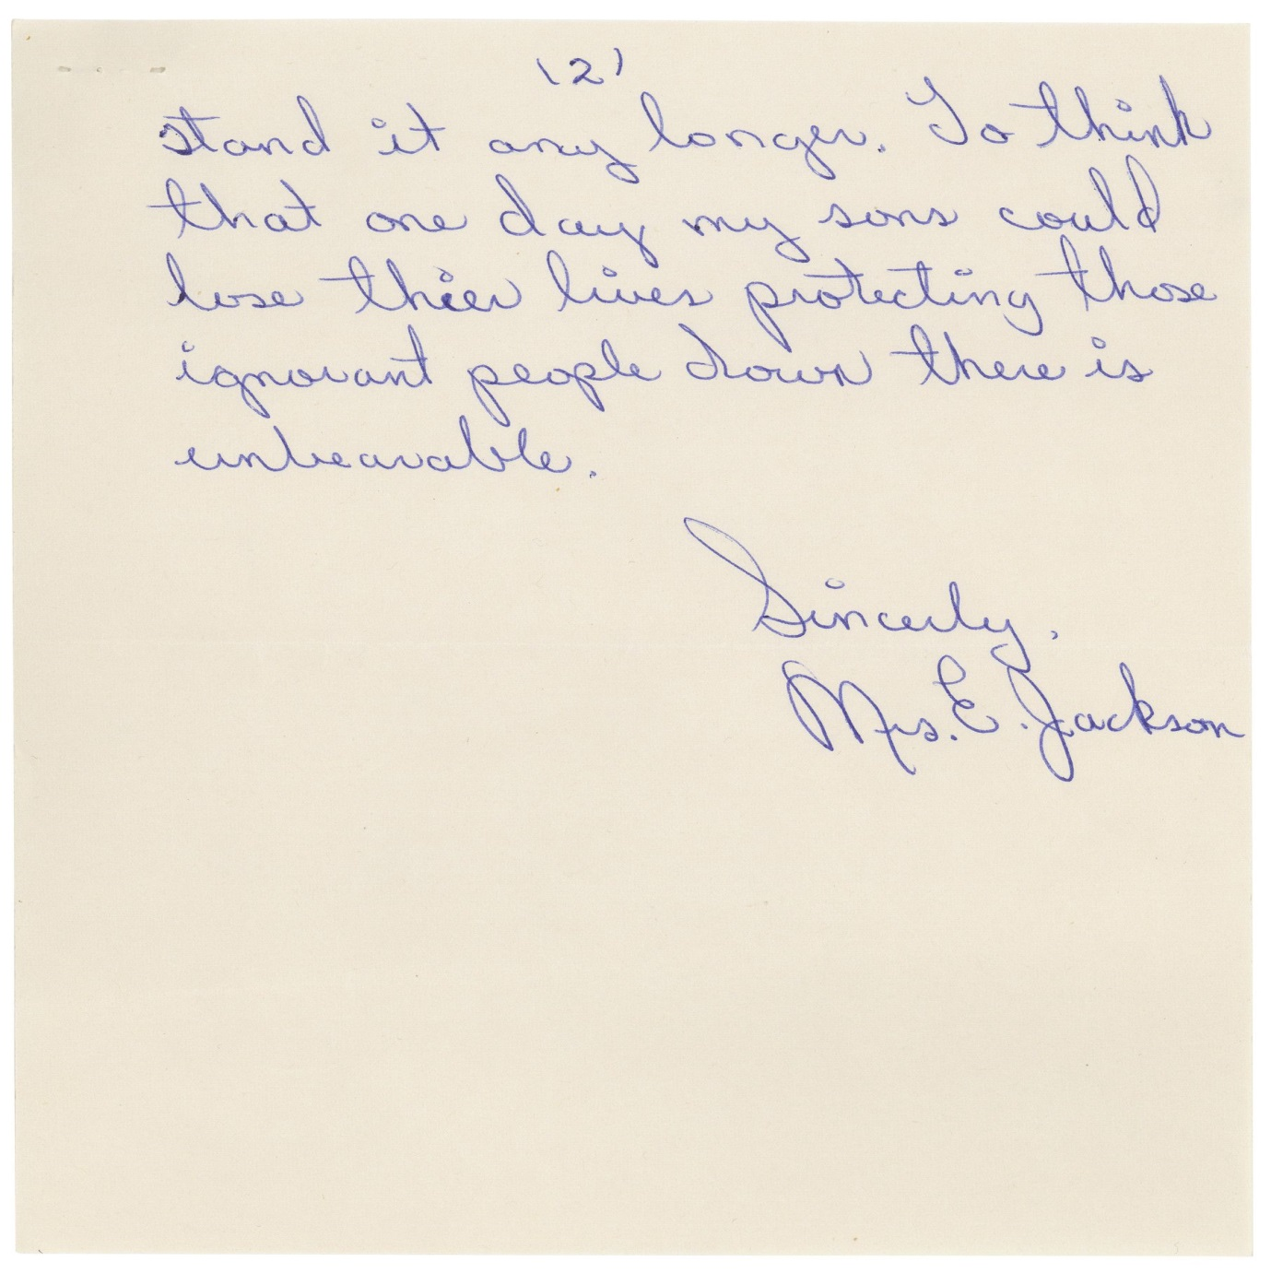

This primary source comes from the Records of the U.S. House of Representatives.

National Archives Identifier: [2173239](https://catalog.archives.gov/id/2173239)

Full Citation: Letter from Mrs. E. Jackson in Favor of Voting Rights; 3/8/1965; Records of the U.S. House of Representatives, Record Group 233. [Online Version, https://www.docsteach.org/documents/document/mrs-e-jackson-in-favor-of-voting-rights, September 9, 2016]

**Text of the Letter**

1460 Sterling Pl. #16

Brooklyn 13, N.Y.

March 8, 1965

Dear Sir:

For God sakes help those poor innocent people in Selma Alabama. If your voice or vote can be of service now is the time to use it. We can’t sit by any longer and watch the shocking events in Ala. Send troops there not overseas and protect those people right to vote. It’s sicken and as a mother of four sons I can’t stand it any longer. To think that one day my sons could lose their lives protecting those ignorant people down there is unbelievable.

Sincerely,

Mrs. E. Jackson

**Response on letter:** Tell her I condemn Gov Wallace for his shameful conduct in ordering use of tear gas and war tactics in Selma and am cooperating with the administration to punish the offenders and to prevent recurrence of the mischief.