**A Strategy for Moving Through Math Anxiety: Maze Moments**

By John T. McCrann on September 15, 2015 7:00 PM  *Education Week*

Most of my students come to my class with some negative associations from their past experiences in math. I've learned that I can't teach them math unless I also teach them strategies for coping with these feelings.

Last semester, my friend and coach [**Nate Dilworth**](http://www.studentachievement.org/about-isa/senior-staff/) introduced me to one such strategy that he first saw in John Young's math class at [**Pablo Neruda Academy**](http://schools.nyc.gov/SchoolPortals/08/X305/default.htm): "Maze Moments."

The research on math anxiety shows pretty clearly that a significant portion of  the anxiety can be alleviated (hat tip to [**Jo Boaler**](https://www.youcubed.org/fluency-without-fear/)). An obvious first step would be to prepare elementary school teachers with the course experience they need to [**overcome their own anxiety in math**](http://www.nytimes.com/2015/09/08/opinion/teachers-arent-dumb.html?_r=0).

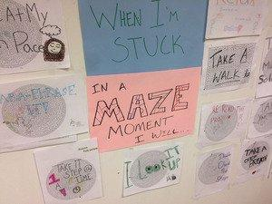

The goal, however, should not be to try to completely eliminate math anxiety.

Real problem solving is inherently messy. Our culture, however, attempts to smooth the rough edges of life. We Google a question and the answer pops up. We are accustomed to easily accessing results so uncertainty and messiness often lead to anxiety.

There are times when this is not the case. There are activities where you expect and enjoy the feeling of getting stuck. For John Young, the maze was this kind of situation: "Something that my students could relate to, something where they had already had the experience of problem solving, but didn't see it that way."

In a few weeks my three-year old nephew will go to the Halloween festival in the rural Virginia town where he will get to play in a maze of hay bales. He will dash in, trying one path. Instead of leading him out, that path will lead him to a dead end. He'll laugh, then begin the process of retracing his steps until he finds a place to make a new turn. Eventually, he'll find the right path and rejoin his Mom and Dad.

Try something. See that it fails. Re-evaluate. Try something new. Repeat until successful. That's problem solving: whether in a maze, math class, science experiment, or relationship.

The power of the "Maze Moments" language is that it explicitly teaches students to anticipate being stuck from time to time in the problem solving process. Naming and normalizing this experience supports all students' ability to think critically and creatively in math.

We can transform math from something that some people are "good at" or "bad at."

"To borrow a couple lines from mathematician [**Paul Lockhart**](https://books.google.com/books?id=7SwyVVKT6WEC&printsec=frontcover&dq=Paul+Lockhart+measurement&hl=en&sa=X&ved=0CCcQ6AEwAGoVChMIou2gn7_rxwIVy82ACh36PQwp#v=onepage&q=Paul%20Lockhart%20measurement&f=false), "It's not only [students] that [are] having trouble understanding mathematical reality; it's all of us....Instead of being tentative and fearing failure or confusion, try to embrace the awe and mystery of it all and joyfully make a mess," Nate, the math coach, explained.

"Discussing 'Maze Moments' can help teachers shift the 'inner monologue' of anxious students: from one that leads to giving up and isolation to 'It's normal to struggle. I'm not the exception in this class.', which can help students begin to get comfortable with 'joyful mess making' in the mathematics classroom."

We can reclaim the feeling of getting stuck in math class. Instead of triggering hurt feelings or embarrassment, math can trigger the happy feelings of playing in a maze.

Last Wednesday, my students spent the first ten minutes of the first day of class working to solve printed mazes. As they worked, they reflected on the strategies they were using and the feelings they had as they got stuck and unstuck. 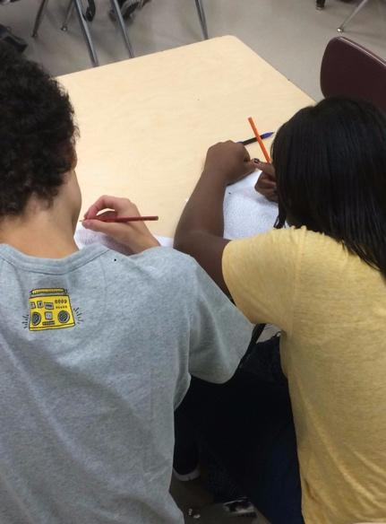

After completing the maze, we developed a list of strategies that are helpful in getting unstuck from a mathematical "Maze Moment:"Retrace your steps. Take a deep breath. Talk about the problem with a friend. Eat something.

Later in class, I sat down at a table with Mark*, who was supposed to be working on a new problem, but wasn't writing. "I think I'm having a 'Maze Moment,'" he told me.

I was happy Mark was able to identify and name his feeling. Naming feelings empowers students to deal with their emotions. Dealing with emotions helps student engage in the messiness of problem solving. Engaging in real problem solving leads to deep math learning and the development of critical thought.

"I agree that  you are in a 'Maze Moment,' that's OK," I told Mark, "let's pick a strategy from our list to help you get unstuck."

And so the real math learning began.

*Student's name changed to protect his identity.*Photo 1: The "When I Get Stuck in a Maze Moment I will..." wall of ideas developed by one of my classes.*

*Photo 2: Two students work on a paper maze in class, they then reflected on this experience.*

