**Maze Moments**

Many moments in life can feel like you are navigating your way through a maze. These are called **Maze Moments.** For instance, when you encounter difficulty in your relationships with family or friends, or when you get stuck on a question in class, these are Maze Moments; you wonder to yourself, what do I do now? What are my choices? How do I handle this situation? As you work on a project or solve a problem, these Maze Moments are important learning opportunities.

**Directions:** There are four mazes for you to navigate your way through. You can start with whichever maze you like. When you hit a dead end, backtrack, or change your approach, *track what you’re doing* by changing colors, using arrows, or making dots.

*Facilitation note: Go for the challenge, pick one you think will challenge you….5 mins to work on mazes*

*Take a moment (1 min) to prep for Think / Pair / Share. When you and your partner are ready*

* **Take a moment to identify (name/describe) the strategies you used during your maze journey in the margins.**
* **Think / Pair / Share:** Compare strategies. What did you do when you got to a place where you encountered a Maze Moment?

*Facilitation note: Have groups share out about similarities and differences in strategies as well as general observations on how they felt as they engaged with the mazes.*

*Have everyone hold up their mazes to observe the art in the process.*

*Follow up with Exit Slip*

**MAZE 1**

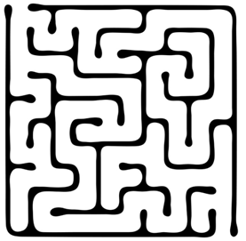

**MAZE 2**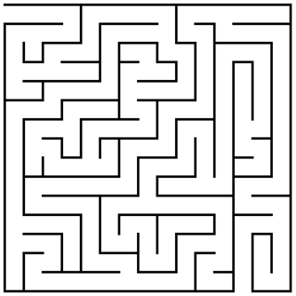

**MAZE 3**

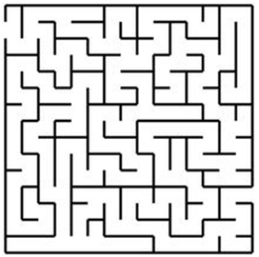

**MAZE 4**

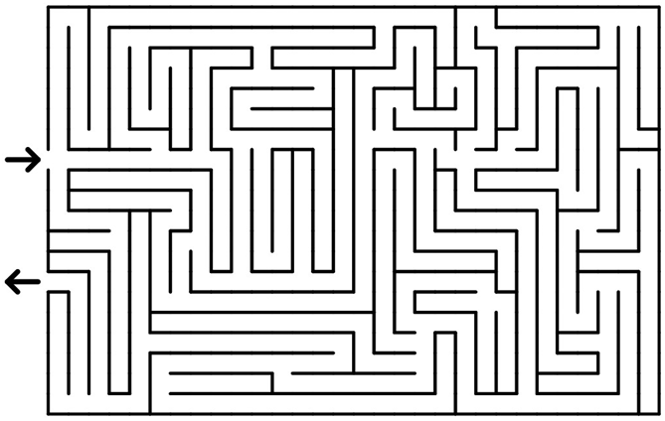

**Exit Slip:**

**Directions: Look at the two images below and then answer the question beneath them.**

|  |  |
| --- | --- |
| **What people think developing understanding and competency is like** | **What developing understanding and competency is really like** |
|  |  |

**Using the images above, please answer this question:** What connections do you make between the images and how learners actually develop understanding and competency?

**________________________________________________________________________________________**

**________________________________________________________________________________________**

**________________________________________________________________________________________**

**________________________________________________________________________________________**

**________________________________________________________________________________________**

**________________________________________________________________________________________**

*Facilitation note: Use this activity to*

* Normalize mistake making and productive struggle as tools to develop understanding
* Provide a shared experience in which students compare notes and work together to learn from inevitable mistakes in order to overcome roadblocks
* Develop new language with positive connotations for naming moments when students make mistakes or feel “stuck”-and for naming strategies for learning from mistakes and getting “unstuck”