Documents for Immigration Writing Activity

Document 1
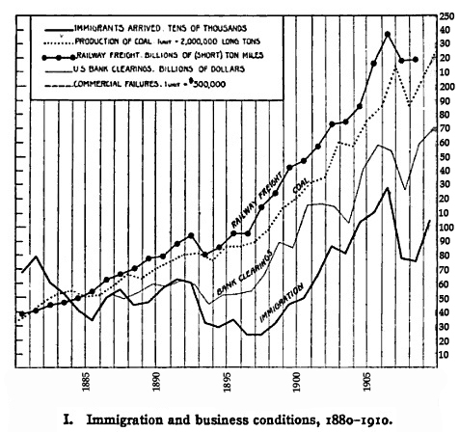
Source:
Hourwich, Isaac Aaronovitch, Immigration and Labor: The Economic Aspects of European Immigration to the United States (New York: G.P. Putnam's Sons, 1912), 87.

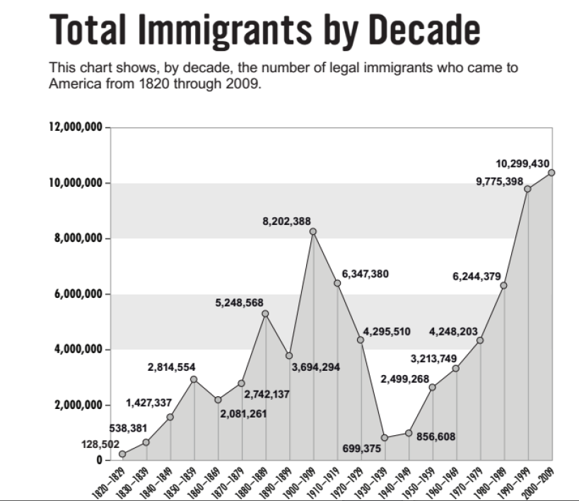



Document 3

“Much has been written about the suffering and discrimination encountered by the Italian immigrant in the United States, but this must be measured against what they left behind at home in Italy. The immigrant at this time left one thing behind and that was poverty. At home there was unemployment, and underemployment, high mortality, little or no medical care, little or no schooling, poor housing, semi-starvation, rigid class structure, and exploitation.”

Source:
Rapcyzynski, Joan, “the Italian Immigrant Experience in America (1870-1920), Yale- New Haven Teachers Institute, Nov. 7, 2013, http://www.yale.edu/ynhti/curriculum/ units/1999/3/99.03.06.x.html

Document 4

“We spent the better part of the day at Ellis Island before my father and my brother came, and they picked us up and took us off. We went to an apartment on East Eleventh Street on the corner of Avenue C. We stayed there about three months. It was a cold-water flat. I came here on December 20, which was quite cold so the only way we got a little heat was, my father would make a stove in the kitchen. Also in the kitchen was an inside
toilet. This was heaven…”

Source:
Coan, Peter. Ellis Island Interviews. New York: Facts on File, Inc., 1997

Document 5

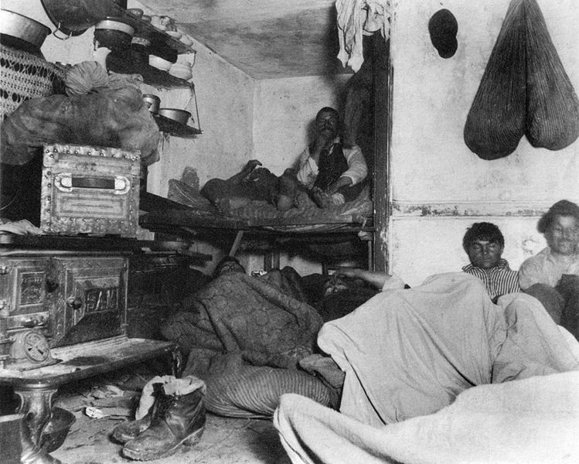

Source:
Riis, Jacob, "Five cent a spot - unauthorized immigration lodgings in Bayard Street tenement", New York, 1890, library of Congress, http://www.loc.gov/pictures/item/2002710259/

Document 6

This letter, originally published in the New York Sun in 1885, was written by Saum Song Bo in response to a fund-raising campaign for the building of a pedestal for the Statue of Liberty. Three years earlier, Congress had passed the Chinese Exclusion Act, barring the further immigration of Chinese to America and denying Chinese the right to become naturalized U.S. citizens.

. . . Seeing that the heading is an appeal to American citizens, to their love of country and liberty, I feel that my countrymen and myself are honored in being thus appealed to as citizens in the cause of liberty. But the word liberty makes me think of the fact that this country is the land of liberty for men of all nations except the Chinese. I consider it as an insult to us Chinese to call on us to contribute toward building in this land a pedestal for a statue of Liberty. That statue represents Liberty holding a torch which lights the passage of those of all nations who come into this country. But are the Chinese allowed to come? As for the Chinese who are here, are they allowed to enjoy liberty as men of all other nationalities enjoy it? Are they allowed to go about everywhere free from the insults, abuse, assaults, wrongs and injuries form which men of other nationalities are free?

SOURCE:
American Missionary, October 1885, 290; in Judy Yung, Gordon H. Chang, and Him Mark Lai, eds., Chinese American Voices: From the Gold Rush to the Present (Berkeley: University of California Press, 2006), 55-56.

